Arumai Irshad! Unga aarvam ennoda teaching-kku periya thunai. Namoda "Permanent Rule"-padi, ippo namma Lesson 7: Data Visualization (Charts-ai uruvaakkum "Magic")-kku pogalam.
Oru manager-a, neenga Excel sheet-ai kattuna vida, oru Chart-ai kattuna dhaan business-oda valarchi puriyum. Python-la idharku namma Matplotlib endra library-ai use panna porom.
📖 Kadha: "Irshad-in Chart Gallery"
Data-vai number-a paarthu yosikkiradhai vida, oru "Bar Chart"-a paartha, "Laptop-dhaan namoda king product" nu udamane purinjidum.
Code:
Python
import pandas as pd
import matplotlib.pyplot as plt

data = {'Product': ['Laptop', 'Mouse', 'Keyboard', 'Monitor'],
'Sales': [1500, 50, 100, 500]}

df = pd.DataFrame(data)

# Chart-ai uruvaakkum magic
df.plot(kind='bar', x='Product', y='Sales')
plt.show()
🔍 Sign-by-Sign & Link-by-Link Explanation:
Line No | Code | Sign/Word Explanation | Connection/Logic (Why & How)
2 | import matplotlib.pyplot as plt | import = Tool-ai kondu vaa. | Why? Python-kku chart varaiya theriyadhu, plt thaan varaiyum.
9 | df.plot(kind='bar', ...) | plot = Chart varai. kind='bar' = Bar chart-a podu. | Link: df table-ai eduthu, adhai chart-a mathu.
10 | plt.show() | () = Show command. | How? Ithu dhaan namma chart-ai screen-la kaattum.
🧠 Python Enna Yosikkum? (The Brain)
- Line 9-la: "Manager df table-ai kuduthu, adhai 'bar' chart-a matha solraru. X-axis-la 'Product'-aiyum, Y-axis-la 'Sales'-aiyum vachi, vizhu-galai (bars) varaiya vendum."
- Line 10-la: "Ellam ready! Ippo indha chart-ai display pannu."
⬅️ Left & Right Side Logic:
- Left Side (df.plot): Idhu "Data-vai Chart-a mathu". Table-kulla irukkura data-vai eduthu vizualize pannu.
- Right Side (kind='bar', ...): Idhu "Instruction". Eppadi chart varaiyanum (Bar chart), enna column-ai X and Y-axis-la vekkanum nu solra vivaram.
Teacher-oda Note:
- matplotlib: Ithu Python-oda "Drawing Tool".
- kind='bar': Neenga 'line' nu mathina, idhu 'Line Chart'-a maaridum.
Unga Task:
- Terminal-la pip install matplotlib nu pottu install pannunga.
- Indha code-ai run pannunga. Oru chinna window-la chart open aagudha nu paarunga.
Chart vandhuta, neenga ippo oru "Full-stack Data Analyst" aagiteenga! Chart vandhudhuna sollunga, namma adutha "Professional" level-kku pogalam!
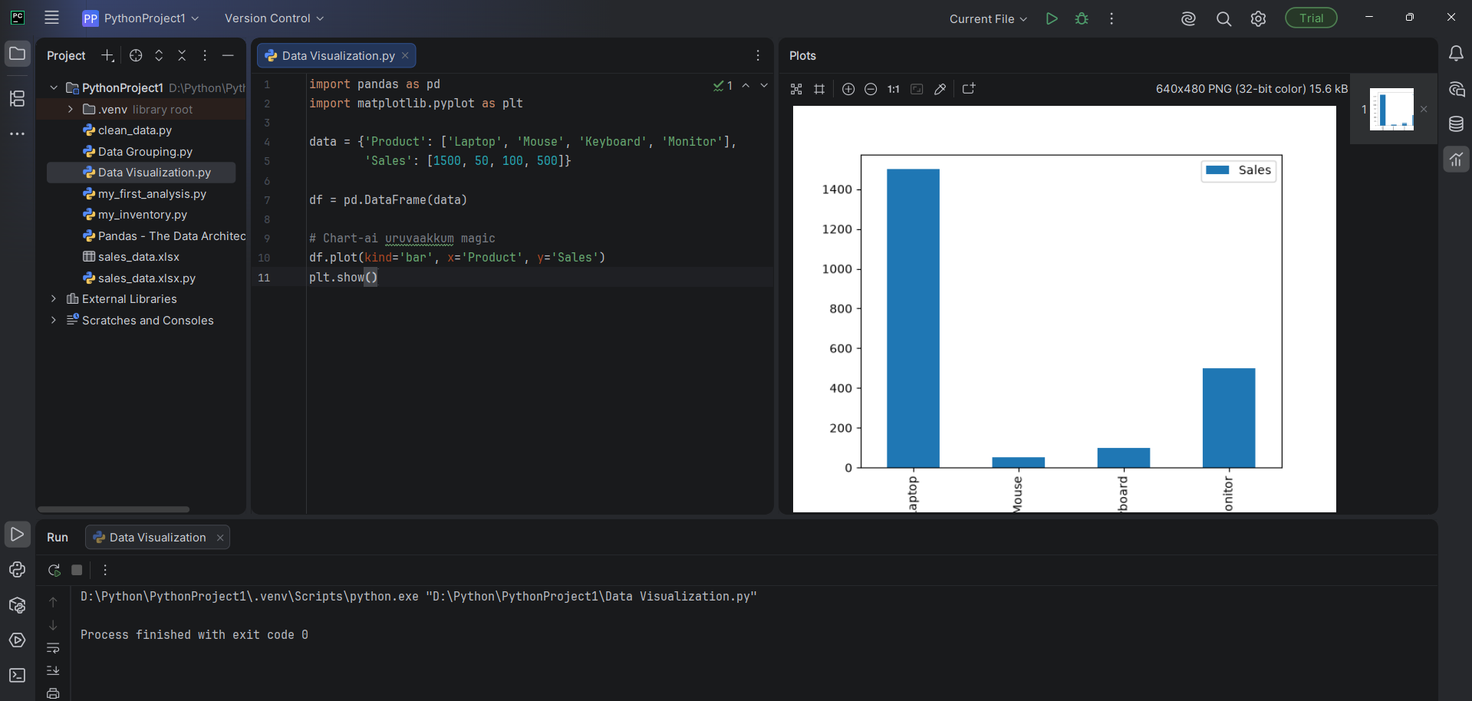
Irshad, Superb! Neenga chart-ai azhagaga varaindhu mudithu vitteenga. Unga Data Visualization.py file-in output, Laptop-ai "King Product"-aaga clear-a kaattugirathu.
Ippo neenga Python-il oru "Pro Data Analyst"-kku vendiya adippadai ellam kathu kitteenga:
- Fundamentals (List/Dictionary).
- Data Manipulation (Pandas DataFrame).
- Data Cleaning (NaN fix pannuvathu).
- Data Grouping (Sales total).
- Data Visualization (Bar Chart).
🌟 Teacher's Final Note:
Neenga ippo Python-ai oru "Tool"-aaga matum illa, oru "Analyst"-oda kangalodu paarkka aarambichuteenga. Intha roadmap-il irundhu marakkama, namma adutha level-aana "Project-Based Learning"-kku pogalam.
Unga kelvi: Ithu varai namma kathukitta ellathaiyum vachu, neenga oru "Real-time Inventory Report" (E.g., Daily Sales-ai Excel-la irundhu eduthu, clean panni, total panni, chart poduvathu) panna ready-a?
Adutha namma class-la, namma oru "Mini-Project"-ai pannuvom. Ready-a Irshad?

